Polypharmacy Action Learning Sets
Presenter Notes

To be used in conjunction with the GP Practice Take Away Slides (available online as part of your Delegate Resource Pack)

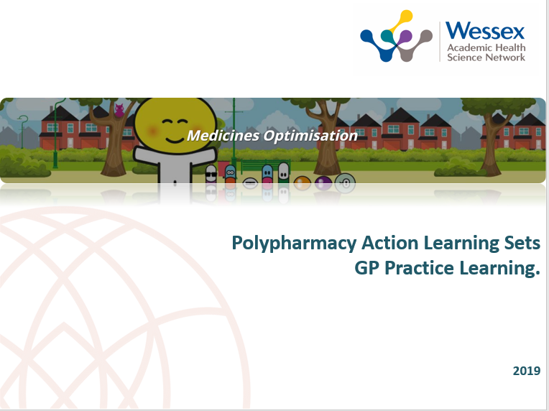

These presenter slide notes have been developed to support you in delivering a lunchtime learning session on your experience and knowledge gained at the recent ALS you attended.

The notes either go into more detail of what is shown on the slide or signposts you to the specific references.

They are intended as a guide only.

Slides 1 – 3:

- No presenter notes

Slide 4: Size and Scale of Polypharmacy

References

1) Parekh, N, et al, Incidence and cost of medication harm in older adults following hospital discharge:
a multicentre prospective study in the UK, Br J Clin
Pharmacol (2018) 84 1789–1797
(2) Cahir C et al (2014). Potentially inappropriate prescribing and adverse health outcomes in community dwelling older patients. Br J Clin Pharmacol. 2014 Jan; 77(1): 201–210.

Slide 5: What are we doing about it?

- No presenter notes

Slide 6: Strategic and Policy Context

References

1) Long term plan
https://www.longtermplan.nhs.uk/wp-content/uploads/2019/01/the-nhs-long-term-plan-summary.pdf

2) Doing things differently and backing the workforce i.e. use of pharmacists
https://www.sps.nhs.uk/articles/about-the-who-medication-without-harm-global-patient-safety-challenge/

The challenge sets out five actions and the NHS has seen the use of QOF to help deliver some of it around polypharmacy. Take early action to protect patients from harm arising from high risk situations, polypharmacy and transitions of care

Further action is cited namely;
-Convene national experts, health system leaders and practitioners to produce guidance and action plans for each of the targeted domains
-Put mechanisms in place, including the use of tools and technologies, to enhance patient awareness and knowledge about medicines and medication use process, and patients’ role in managing their own medications safely
-Designate a national coordinator to spearhead the Global Patient Safety Challenge on Medication Safety
-Assess progress regularly
3) QOF
https://www.england.nhs.uk/wp-content/uploads/2019/05/gms-contract-qof-guidance-april-2019.pdf

QI activities we need to do (example);

- Baseline practice prescribing analysis identifies patients on regular NSAID prescriptions with a recorded contraindication.
- Baseline practice prescribing analysis shows only 5% of patients obtaining a regular (repeat) NSAID have had a clinical safety risk assessment clearly documented within the last 12months.

A new DES for structured medication review (SMR) will be in the 2020 GP contract and will include high risk groups of patients that should receive an SMR.

STOMP - Stop Over Medication Programme target for patients with learning disabilities and autism
Make this clear that you can make this part of business as usual.

Slide 7 – 11

- No presenter notes

Slide 12: What about patients?

- It is possible to estimate the reduction in the number of patients receiving the relevant combinations of medications for some comparators
- This involves calculating the difference between the actual number of patients for a comparator in June 2019 and the number that would have been expected had the actual number in June 2017 changed by the same proportion as the denominator by June 2019
- By June 2019 there were around 58,300 fewer patients receiving two or more DAMN medicines than would have been expected if their numbers had decreased in line with the number of patients receiving one or more DAMN medicines between June 2017 and June 2019
- NOTE: The numbers shown the table below for the different comparators should not be added together into a total as some patients could be included in more than one comparator

Slide 13 – 14
- No presenter notes

Slide 15: Prescribing we should be concerned about…

- Ask attendees which drugs they think are red flag drugs – once again, it is important to remind your audience that increasing age increases the risk with any of this
- Essentially, they are the ones that we know through the literature cause the greatest number of unplanned hospital admissions such as NSAIDs, Anticoagulants, Anti-platelets and diuretics
- Practitioners should always think about “red flag” drugs in the same way as diagnostic red flags
- Link why NSAID audit part of the QOF QI work
- Ask attendees which drugs they think are concerning combinations

Examples to prompt the discussion could include: DAMN drugs (Diuretics, ACEI/Angiotensin antagonists/ Metformin / NSAIDs – Explain use of CrCl calculator on S1 / EMIS
Anticholinergics – CNS drugs e.g. opiates / GABA / Antidepressants / Antipsychotics / Anxiolytics

Note: PINCER or the NHS BSA National Polypharmacy Prescribing Comparators will help you to identify these types of patients in your practice. (This work is a 2019 HSJ Patient Safety Award winner).

Slide 16: Victim or villain?

- Remember, we are all part of a complex and over-burdened system so no one is at fault specifically and together we can make a difference

Slide 17

- No presenter notes

Slide 18: Behavioural Tools to address problematic polypharmacy

Links to websites:

Magic (https://www.health.org.uk/funding-and-partnerships/programme/magic-shared-decision-making)

Me & My Medicines (https://meandmymedicines.org.uk/ and https://wessexahsn.org.uk/projects/321/me-and-my-medicines)

DES (https://www.england.nhs.uk/wp-content/uploads/2019/03/network-contract-des-guidance-2019-20-v2.pdf)

NHS Scotland (https://www.gov.scot/publications/good-practice-shared-decision-making-consent/)

Slide 19: Technical Tools to address problematic polypharmacy

Explain there are more explicit tools e.g. Stop Start but to keep it simple these are the 2 suggested approaches as we feel they are very pragmatic;
- Scottish Polypharmacy guidance is current gold standard for a person-centered consultation with evidence for risks vs benefits for stopping lots of common medicines
- No Tears model simple designed by a GP pre person-centered care in 2004

Slide 20: Technical Tools to address problematic polypharmacy

No Tears Model (detailed explanation)

NOTEARS

Need and indication—Does he know why he takes each drug? Does he still need them? Was long term treatment intended? Is the dose appropriate? Has the diagnosis been refuted? Would non-pharmacological treatments be better?

Open questions—Give him the opportunity to express his views by asking questions: “I realise a lot of people don't take all their tablets. Do you have any problems?” “Can I check that we both agree what you're taking regularly?” or “Do you think your tablets work?” Compare his replies with the number of prescription requests.

Tests and monitoring—Assess disease control. Are any of his conditions undertreated? Get advice on appropriate monitoring from prescribing guidelines such as the British National Formulary or the US Physicians' Desk Reference and other primary care documents.

Evidence and guidelines—Has the evidence base changed since his prescription was initiated? Do the prescribing guidelines indicate that any of his drugs are now less suitable for prescribing? Is the dose appropriate? (For example, dose optimisation of angiotensin converting enzyme inhibitors in cardiac failure.) Are other investigations now advised, such as echocardiograpy or testing for Helicobacter pylori?

Adverse events—Does he have any side effects? Is he taking complementary medicines or over the counter preparations? Check for interactions, duplications, or contraindications. Remember the “prescribing cascade” (misinterpreting an adverse reaction as a new medical condition).

Risk reduction or prevention—If time allows, update opportunistic screening. What are his risks, such as of falls? Are the drugs optimised to reduce these risks?

Simplification and switches—Can treatment be simplified? Does he know which treatments are important? It may be better to replace low doses of several agents by one full dose. Explain any
switches that increase the cost effectiveness of treatment.

Slide 21: Scottish Polypharmacy Guidance

Links to more information

Scottish Polypharmacy 7 steps is very much about person centred care and need for shared decision making. For more information visit https://www.therapeutics.scot.nhs.uk/wp-content/uploads/2018/04/Polypharmacy-Guidance-2018.pdf. It is also available as an app

It is also worth consulting “Polypharmacy Guidance NHS Education for Scotland”

Slide 22: Untitled

References

To gain full access visit: https://www.therapeutics.scot.nhs.uk/wp-content/uploads/2018/04/Polypharmacy-Guidance-2018.pdf and consult the table in detail

Slide 23: Barriers to stopping medicines

Suggest/invite comments from attendees and then share the answers collated / you found most interesting from the ALS. Key themes that come up repeatedly include but are not limited to;
- Confidence to stop
- Time pressures
- Resources
- Patient expectations
- Different healthcare professionals to stop medicines have different priorities re stopping medicines

